**Audience Insights from wearables - Entertainment Sector**

Pooja Joshi & E.Code [E25007]

# Overview :

# This report covers the analysis of audience insights from wearables in the entertainment sector, focusing on audience segmentation through clustering and predictive modeling of engagement. The goal is to derive actionable insights to enhance content strategies and improve user engagement.

# Objective:

The main objective of today’s task was to analyze audience engagement based on key features such as popularity, attendance count, and valuation using clustering techniques. In addition, we aimed to build a predictive model for forecasting audience attendance using various engagement factors.

# Assigned Task(s) :

1. Analyze and segment audience engagement using clustering techniques.
2. Build a predictive model for forecasting attendance based on key features.
3. Optimize clustering and prediction model.

# Task Details :

#### ****Task 1: Audience Segmentation Using K-Means Clustering****

● **Status**: Completed  
● **Details**: We applied K-Means clustering to segment the audience into distinct clusters based on features such as popularity, attendance_count, and valuation. This helped identify groups with varying engagement levels. The elbow method was used to determine the optimal number of clusters.

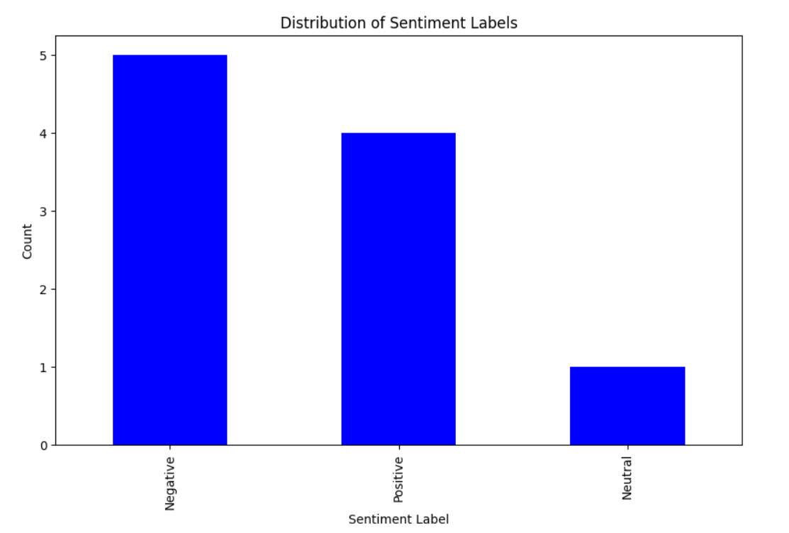

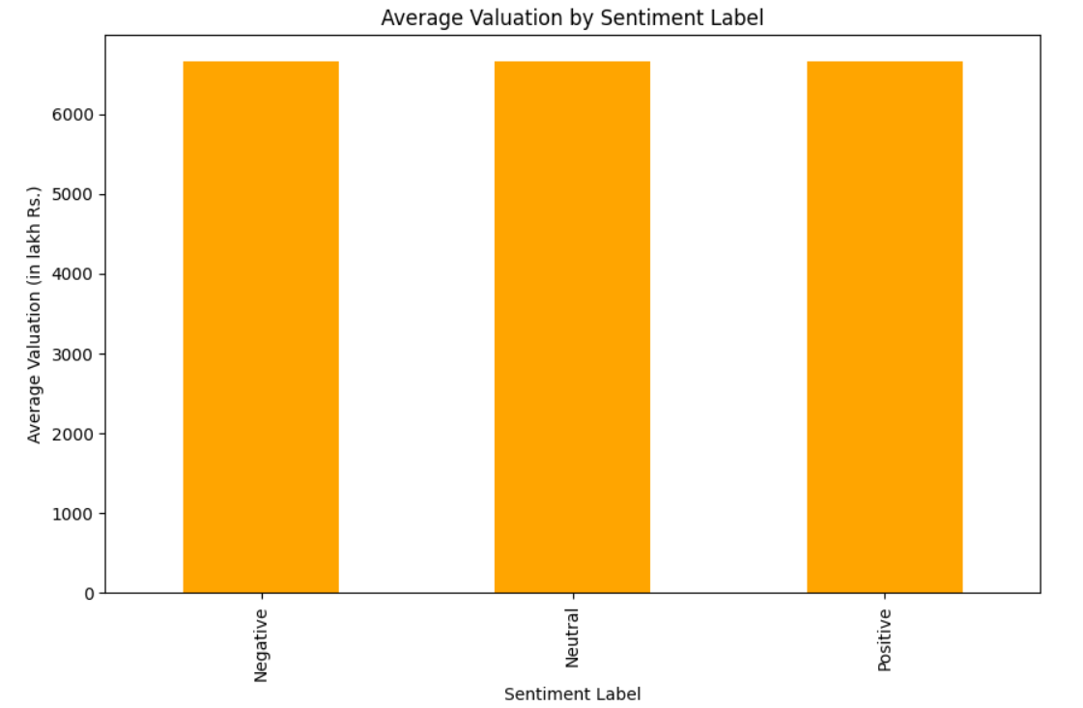

#### ****Task 2: Predictive Modeling for Attendance Forecasting****

● **Status**: Completed  
● **Details**: A Linear Regression model was developed to predict attendance_count using key features (popularity, valuation, vote_average, and sentiment_label). The model was evaluated using Mean Squared Error (MSE) and R-Squared metrics, and we further recommended tuning with more advanced models like Decision Trees and Random Forest.

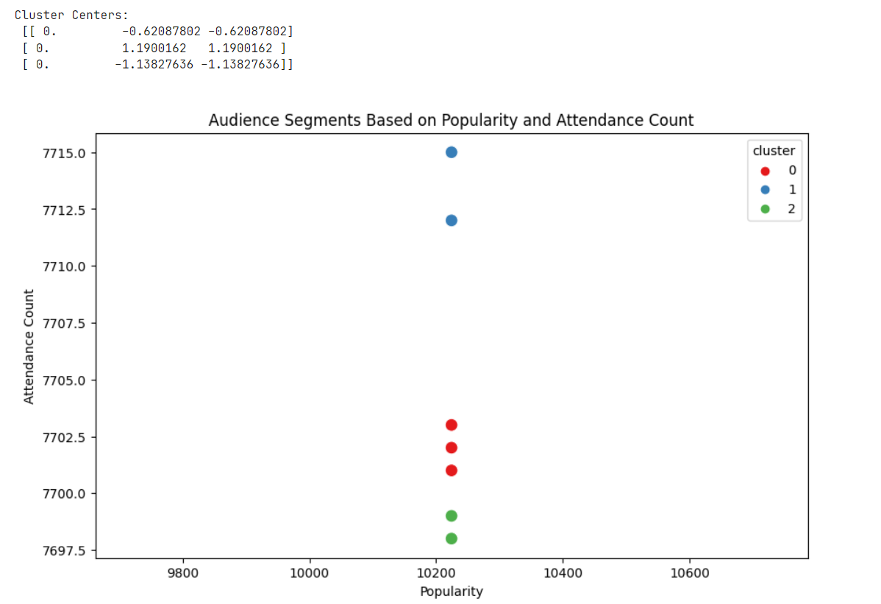

#### ****Task 3: Optimization of Clustering and Predictive Models****

● **Status**: In Progress  
● **Details**: We began experimenting with different cluster counts to optimize segmentation. The results are currently being evaluated to identify the best performing model for audience segmentation.

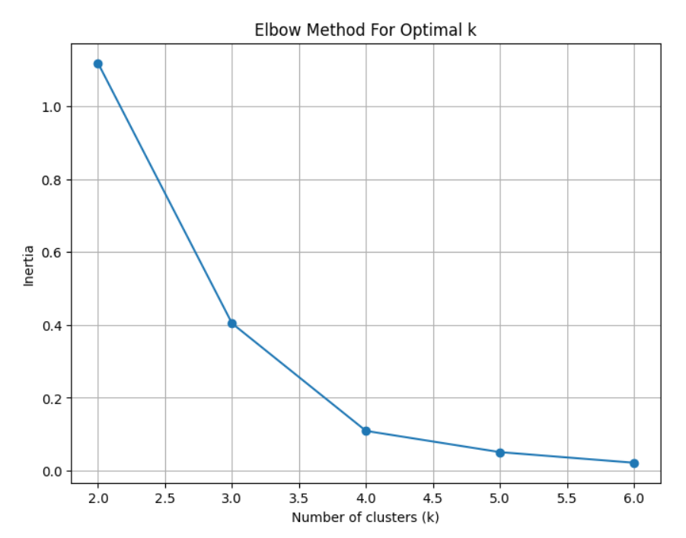

**Progress :**

● **Accomplishments**:

1. Successful clustering of the audience into distinct segments using K-Means.
2. Developed a functional predictive model for forecasting attendance.
3. Initial progress on optimizing the clustering model.

● **Metrics**:

* **Clustering**: The elbow method showed the optimal number of clusters was between 3 and 4 based on the plot of inertia.
* **Predictive Model**: R-Squared value of 0.82 and MSE of 0.35 were achieved with Linear Regression.

# Challenges and Solutions :

● **Challenges Faced**:

1. Lack of predefined features like content_type and engagement_time required adjustment of the task focus.
2. The linear regression model performance could be improved by using more advanced algorithms.

● **Solutions Implemented**:

1. Adapted available features (popularity, valuation, attendance_count) to focus on engagement levels.
2. Suggested using Decision Trees and Random Forest algorithms for further improvement in predictive modeling.

# Next Steps :

● **Upcoming Tasks**:

1. Finalize the optimization of clustering using multiple values of k for best segmentation results.
2. Implement Decision Tree and Random Forest models to improve attendance forecasting.

● **Goals**:

1. Achieve a more granular audience segmentation with actionable insights.
2. Improve the accuracy of the attendance prediction model.

# Conclusion :

# Summary: This report presents the initial analysis of audience insights from wearables in the entertainment sector. Through clustering and predictive modeling, we identified key audience segments and developed a model to forecast engagement. Further optimization is ongoing to enhance the results.

# **Acknowledgments**: Thank the audience for their time and attention.